

**CSA1070-Software Engineering For Process Analysis System**

**DEEPAK P**

**192211034**

**Department Of Computer Science**

**LAB EXPERIMENTS**

* **CLASS DIAGRAM**
* **USE - CASE DIAGRAM**
* **ACTIVITY DIAGRAM**
* **RAPTOR**
* **CYCLOMATIC COMPLEXITY**

**1. Draw a Use Case diagram for Online Voting System using CASE tools.**

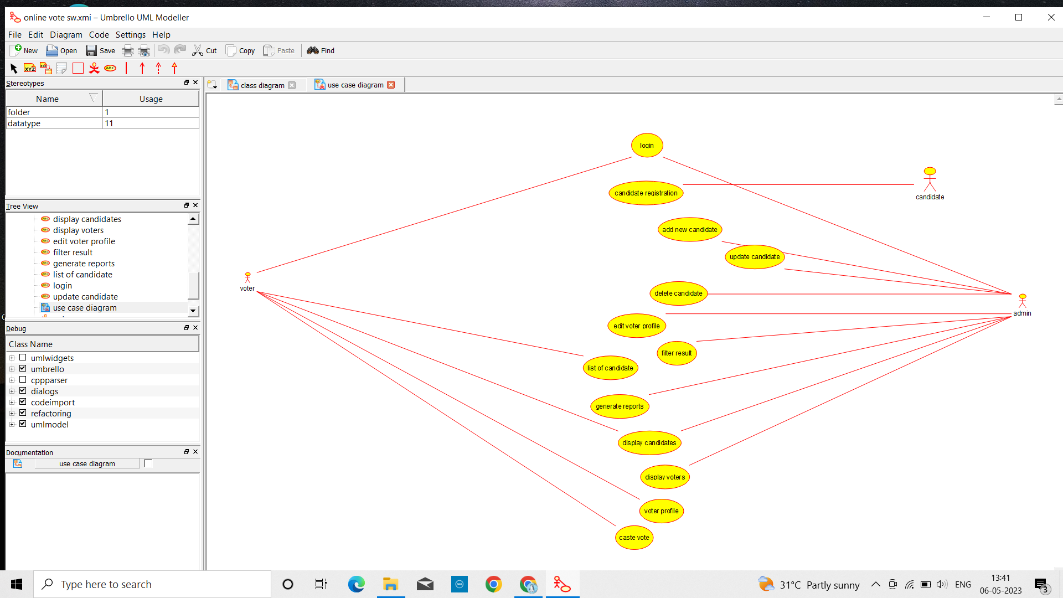

**2. Draw a use case diagram for Library Management System is an automation system used to manage a library and the different resource management required in it like cataloguing of books, allowing check out and return of books, invoicing, user management.**

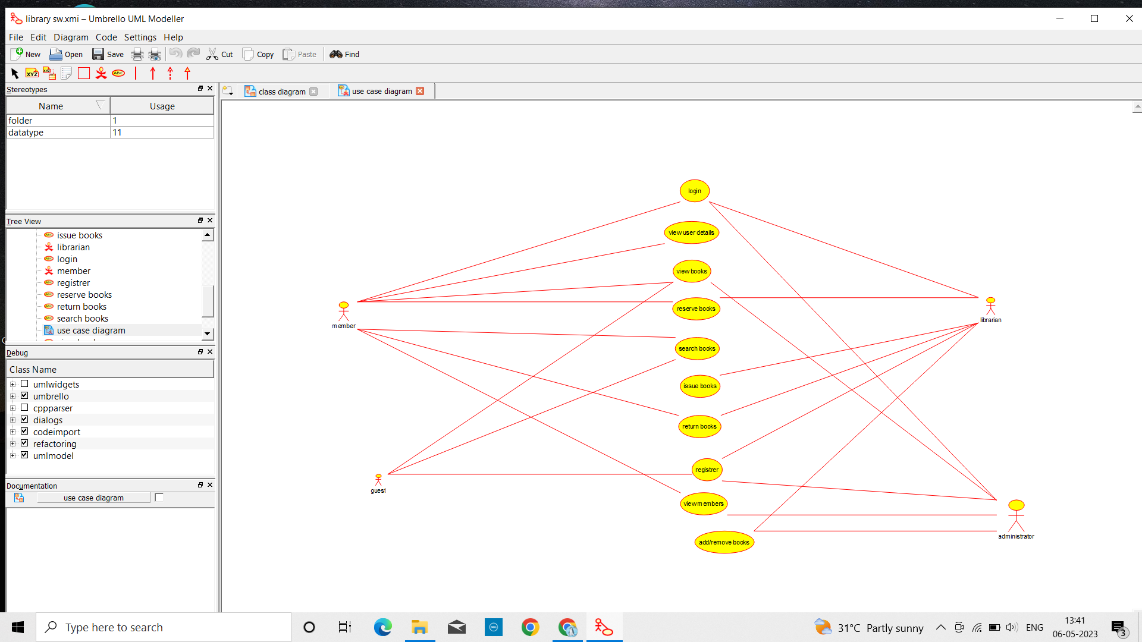

**3. Draw and validate Flowchart to compute quotient and remainder between two integers can be calculated by using the division ( / ) and modulus ( % ) operators respectively. To compute the remainder of the division of two floating point numbers, the library function fmod() is used. This function considers quotient as an integer number and the remainder as a floating-point number**

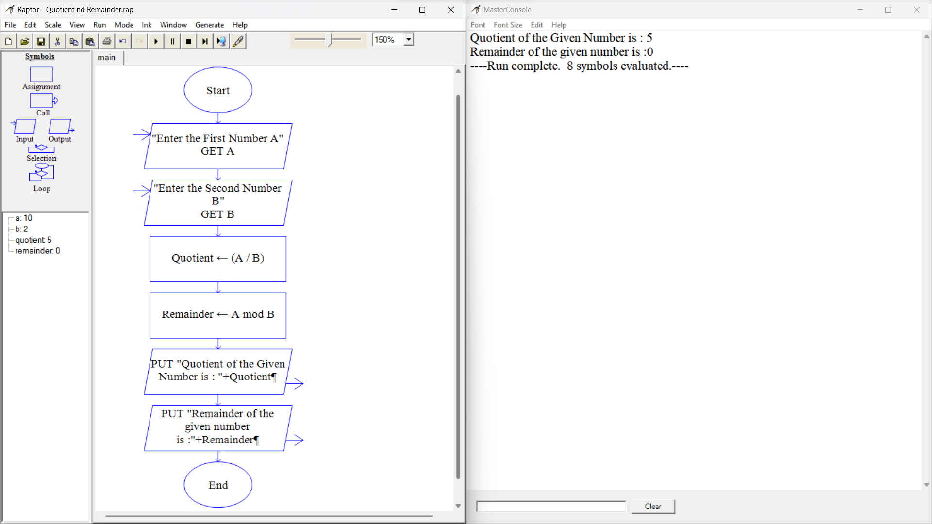

**4. Design a shopping cart system. How is the cart updated when the application is open on multiple pages? When an item is added to the cart, store the update in the server. Therefore, a page refresh on any tab will keep everything up to date. If you don't want to rely on a refresh, you could try some sort of polling mechanism. If the web browser on Focus event happens (assuming it's there), poll the server for a quick update if there is one.**

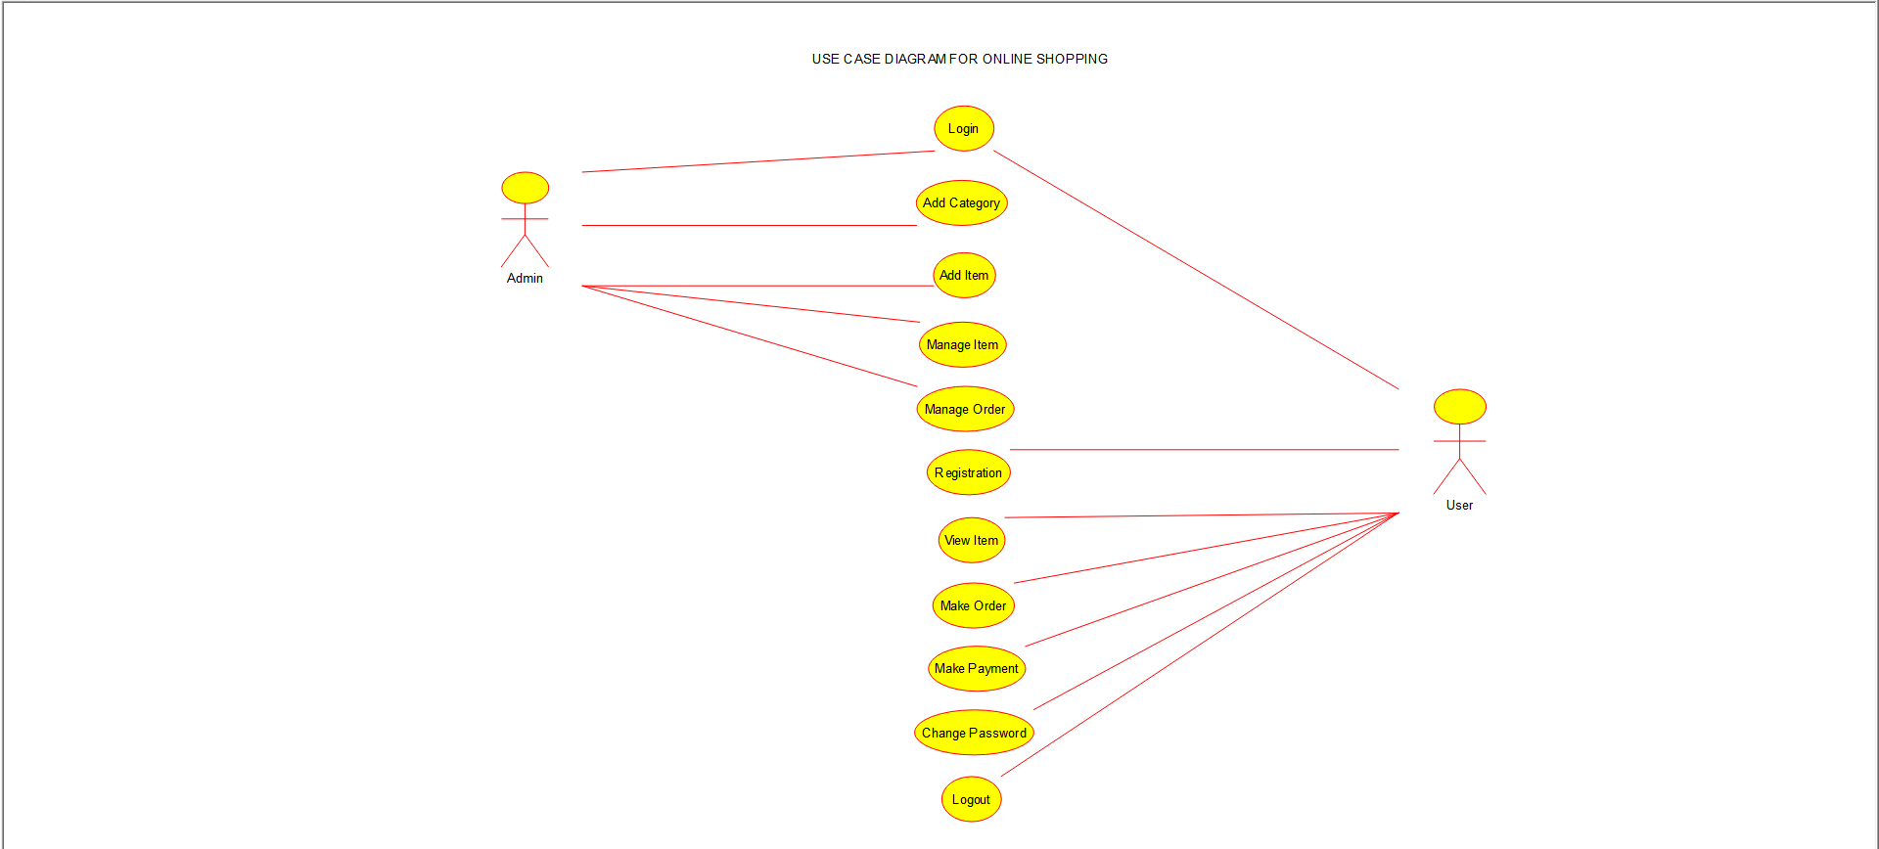

**5. Draw the use case diagram is a graphic depiction of the interactions among the elements of the Railway reservation system for maintaining admin user can search ticket, view the description of a selected ticket, add a ticket, update a ticket and delete a ticket and it shows the activity flow of editing, adding and updating of the customer.**

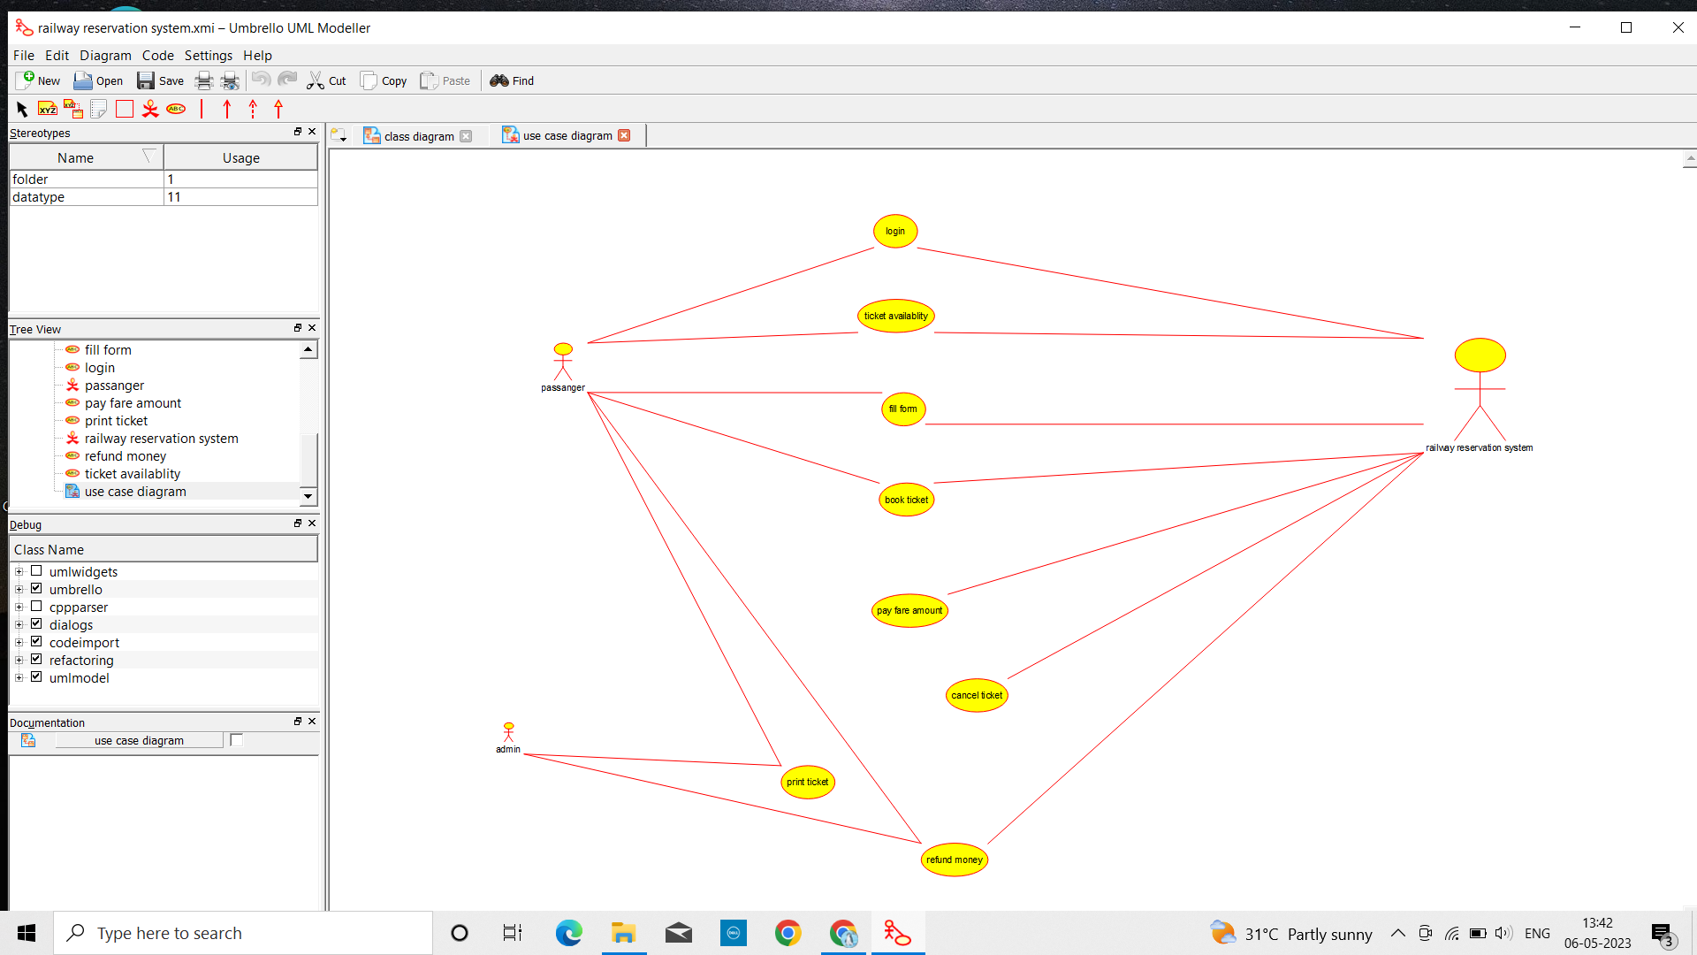

**6. Draw a USE-CASE diagram for the Hospital Management System. The activities of the hospital system are listed below.**

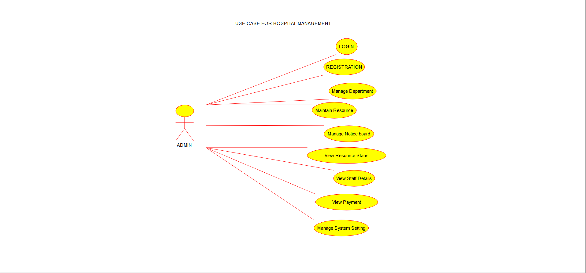

**7. Draw a USE-CASE diagram for an ATM System using CASE tool.**

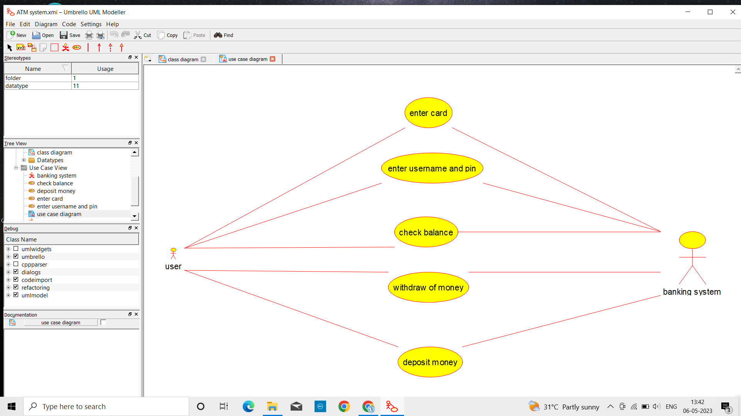

**8. Draw a USE-CASE diagram for Online college management System Manage student’s information and status, manage courses and subjects, Manage Instructors and designation, record all transactions Draw a USE-CASE diagram for Online Airline Management System which is a dedicated and highly configurable system for all airlines, which can be easily accessed by all users.**



**9. Make an Online Airline Reservation System using USE-CASE diagram.**

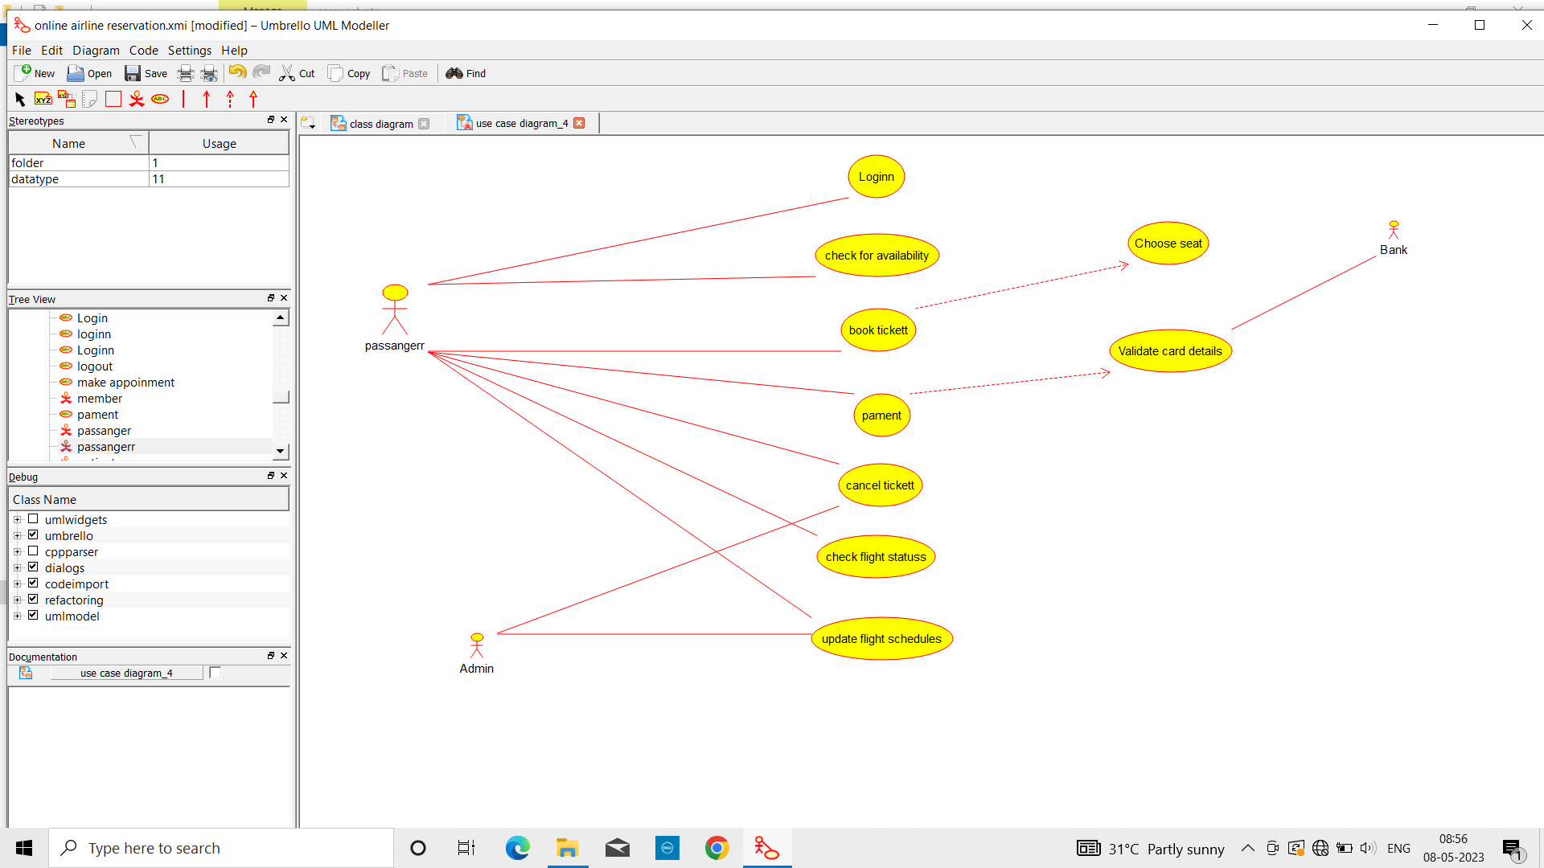

**10. Make an Online Airline Reservation System. The activities of the Online Airline Reservation system are listed below user, admin, LOGIN, MANAGE CLASSES, MANAGE WAITING LIST, MANAGE HOLDS, MANAGE DEADLINES, LOGOUT, using this has a step-by-step process draw a CLASS diagram Draw a Class diagram for Library Management System using CASE tools.**

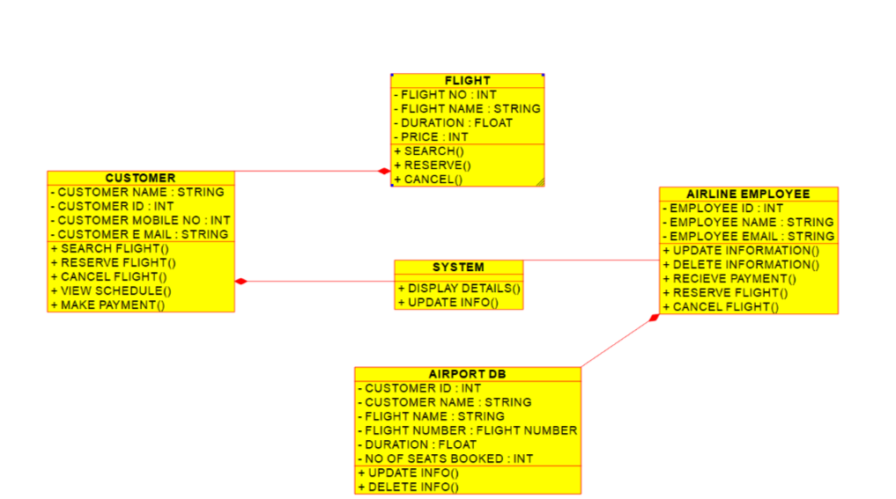

**11. Draw a Class diagram for Online Voting System using CASE tools.**

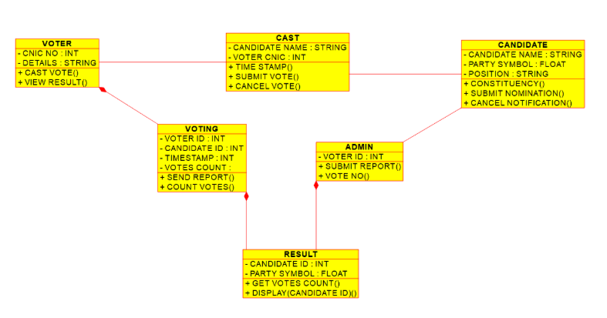

**12. Draw a Class diagram for Library Management System using CASE tools.**

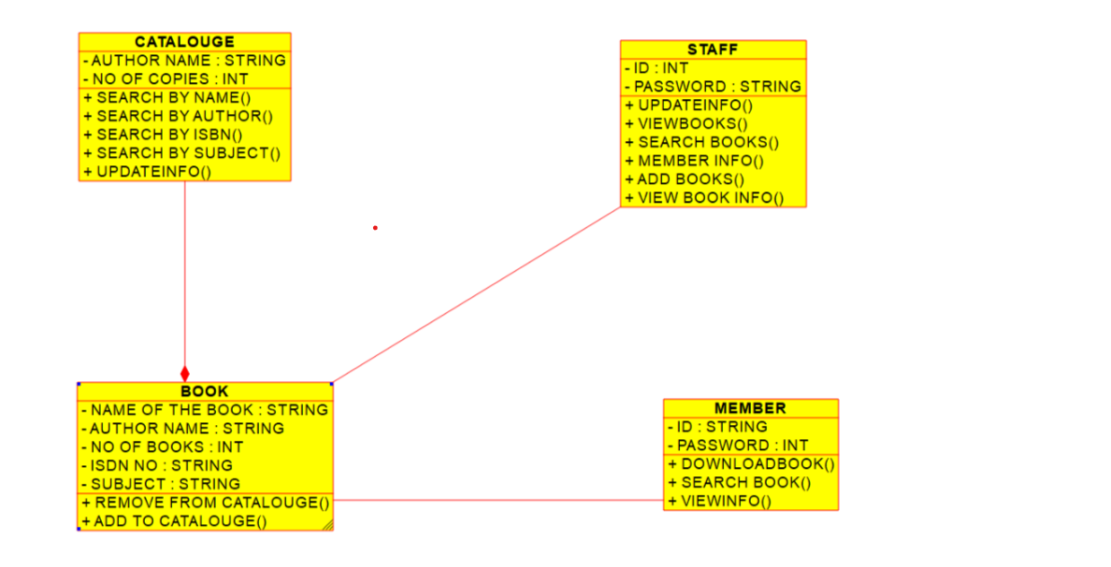

**13. Draw a Activity diagram for Online Voting System for a software platform using CASE tools.**

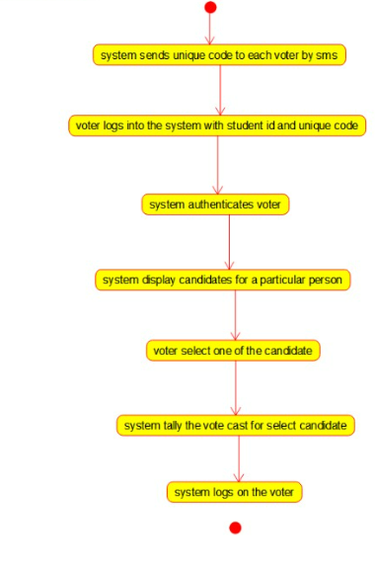

**14. Draw a Activity diagram for Library Management System using CASE tools.**

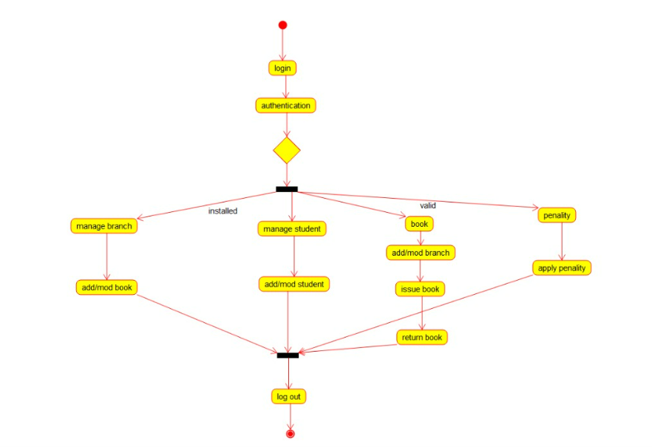

**15. Draw an Activity diagram for the Online Shopping system using CASE tools.**

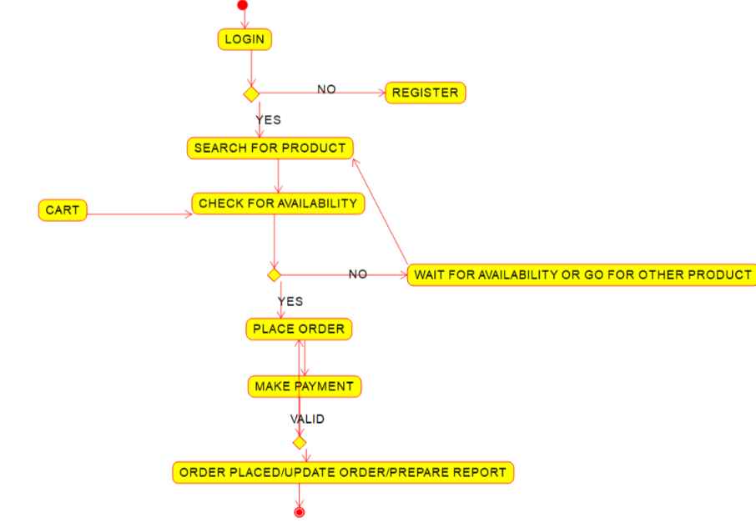

**16. Draw an Activity diagram for Online Railway Reservation System using CASE tools.**

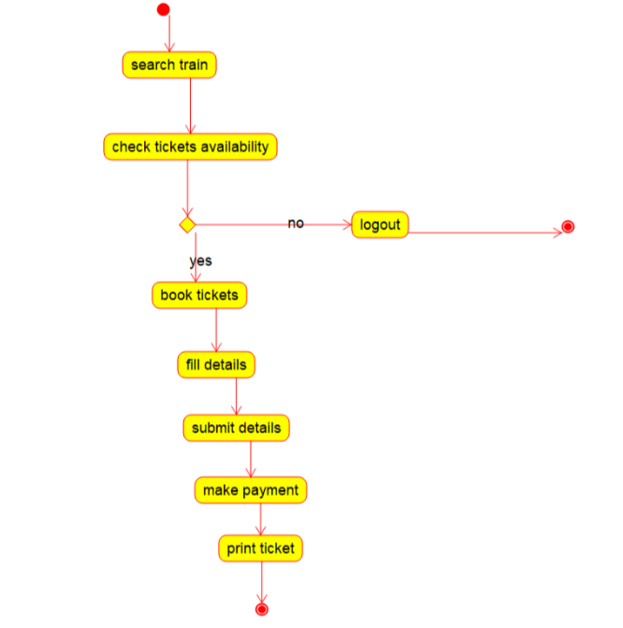

**17. Draw an Activity diagram for Hospital Management System using CASE tools.**

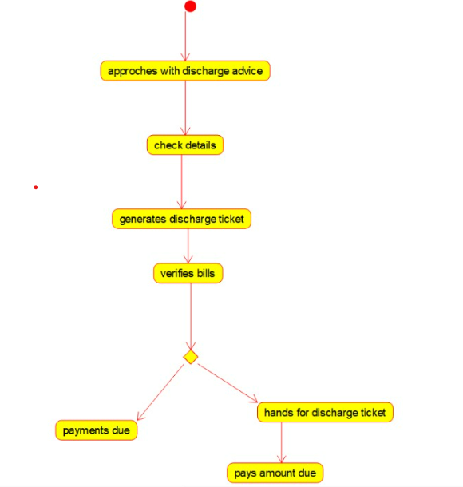

**18. Using Raptor- Draw the flowchart to check whether the given number is a palindrome or not.**

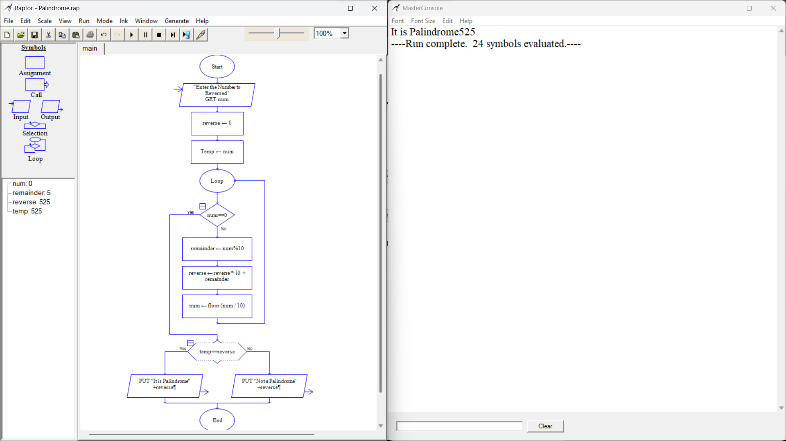

**19. Draw a Activity diagram for Hospital Management System using CASE tools.**

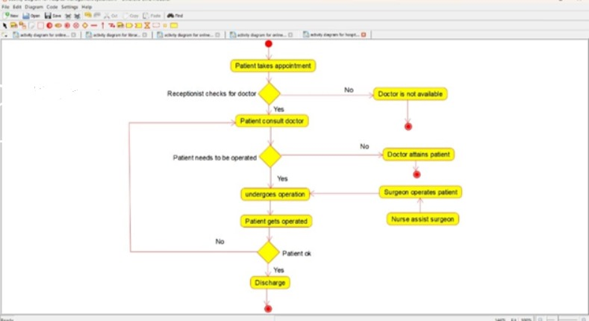

**20. Using Raptor draw a flowchart to display the total number of characters in the string and return it.**

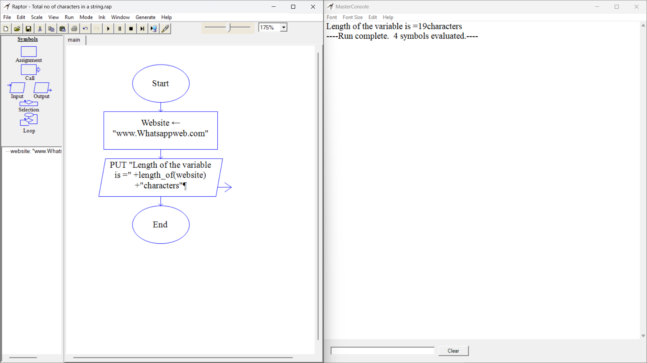

**21. Using Raptor, draw the flowchart to find whether p and q are prime or not.**

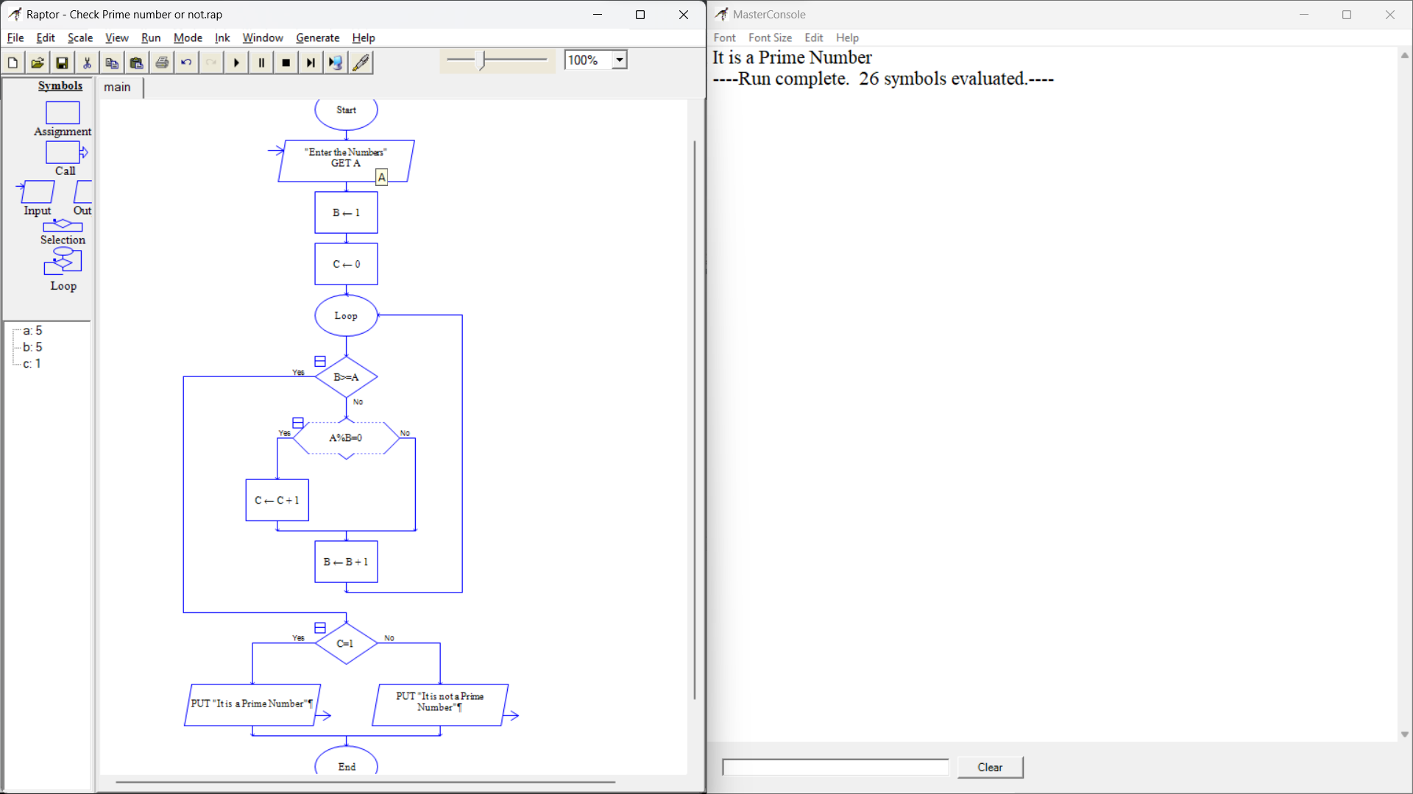

**23. Design an activity diagram for an automated online banking system.**

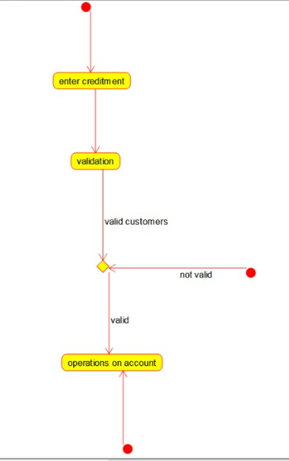

**24. Develop an activity diagram for an e-library online public access catalogue.**



**25. Draw a Class diagram for an e-library online public access catalogue.**



**26. Draw a Use Case diagram for a Restaurant Systems.**

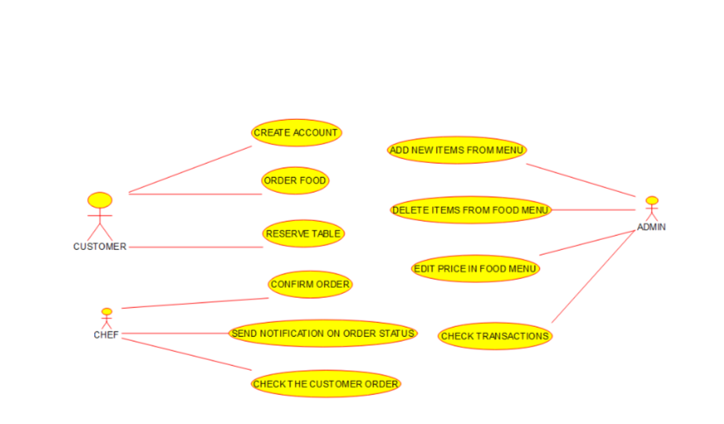

**27. Draw a Class diagram for a Restaurant Systems.**

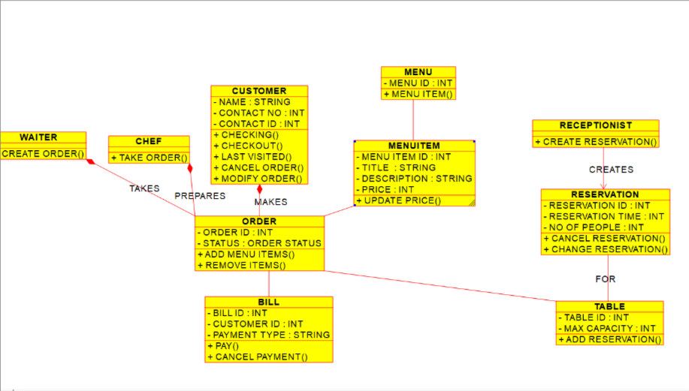

**28. Make a class diagram to model for a quiz system.**

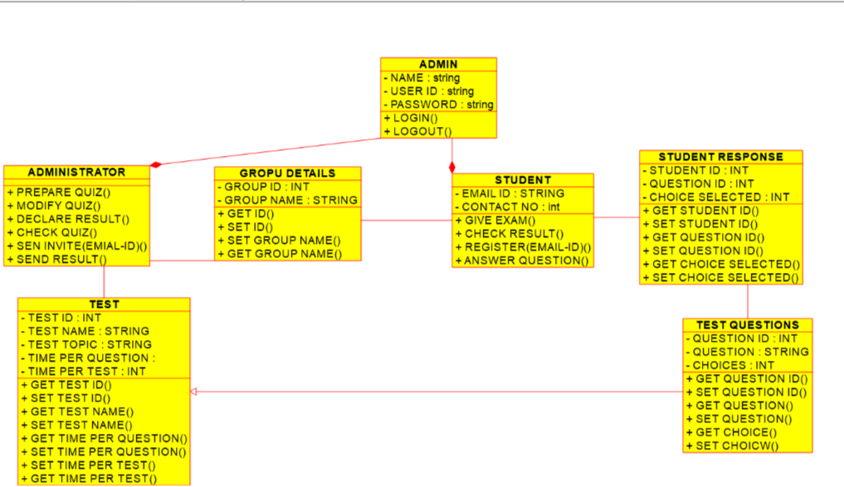

**29. Draw a Use case diagram to model for a quiz system.**

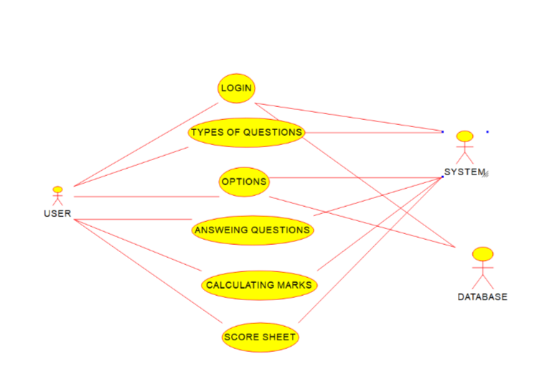

**30. Using Raptor- Draw and validate the flowchart to calculate Factorial of a number**

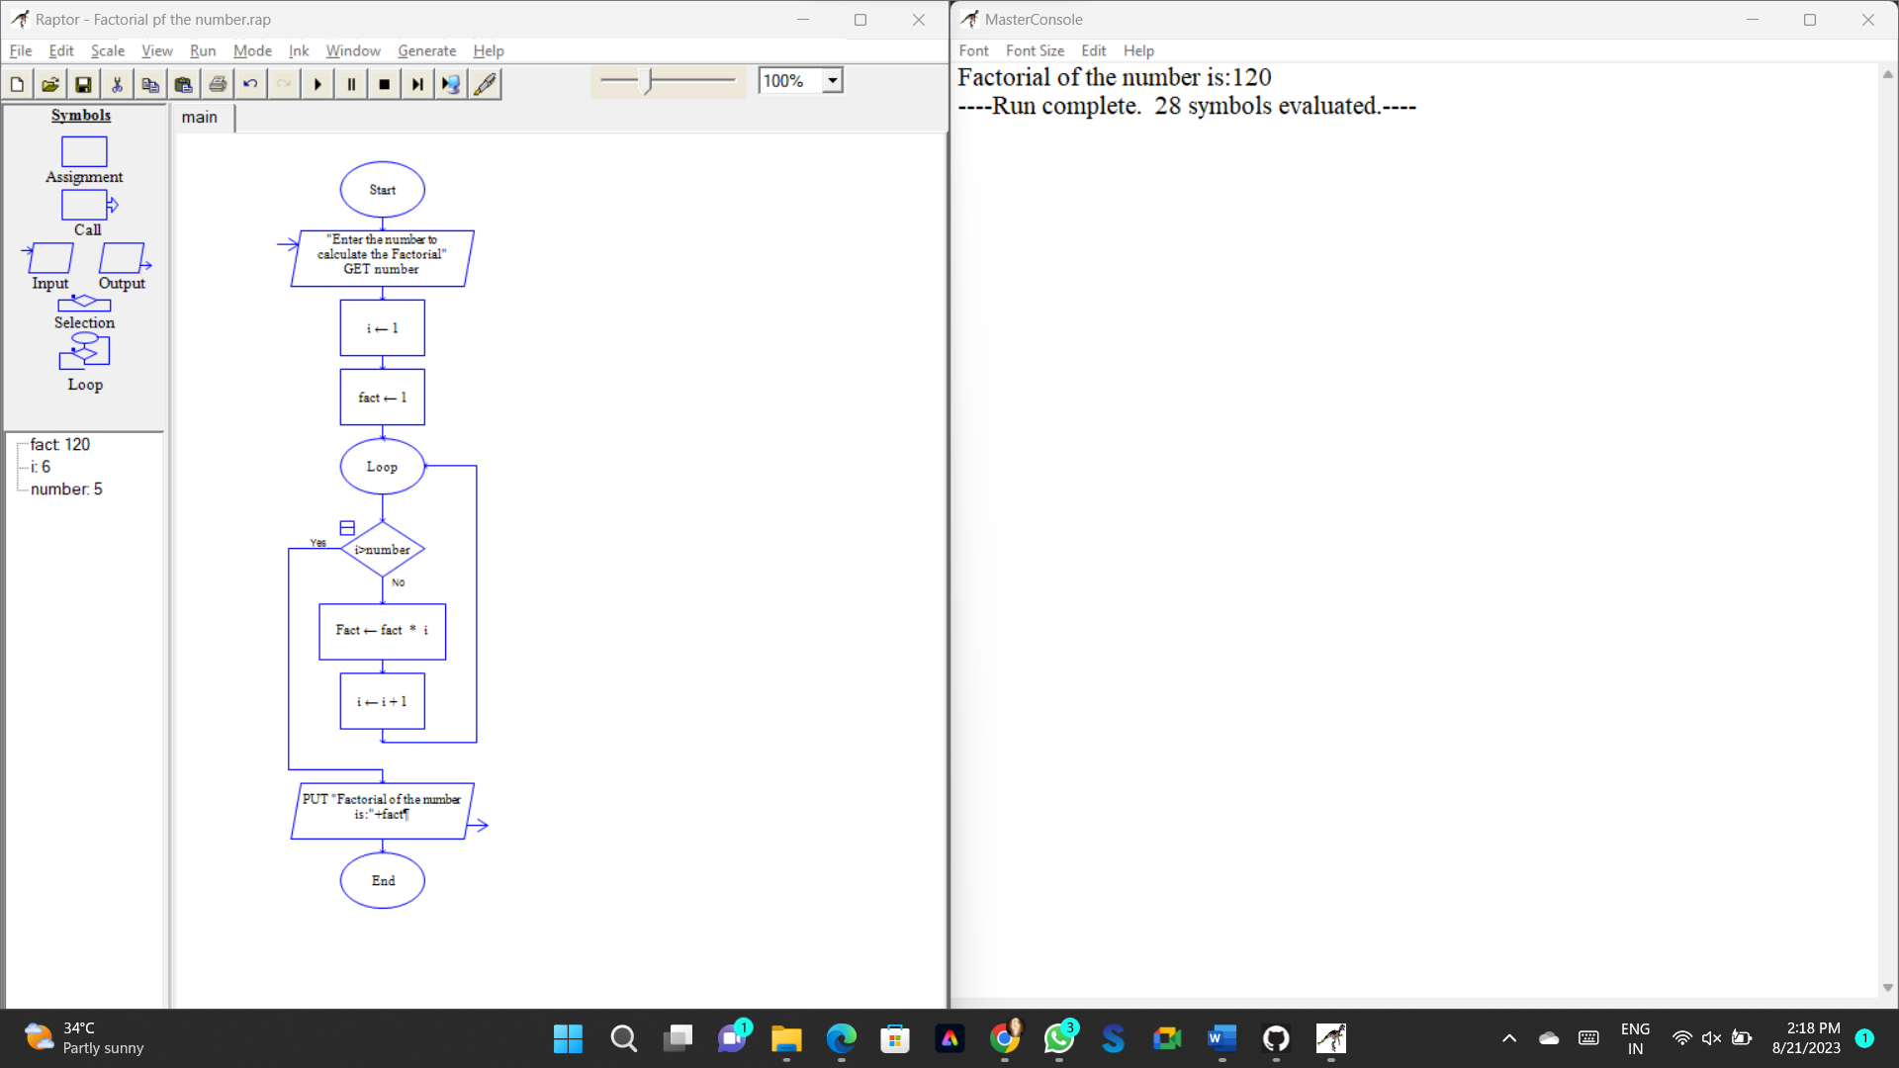

**31. Using Raptor – Draw and validate the flowchart to find odd series of the given number.**

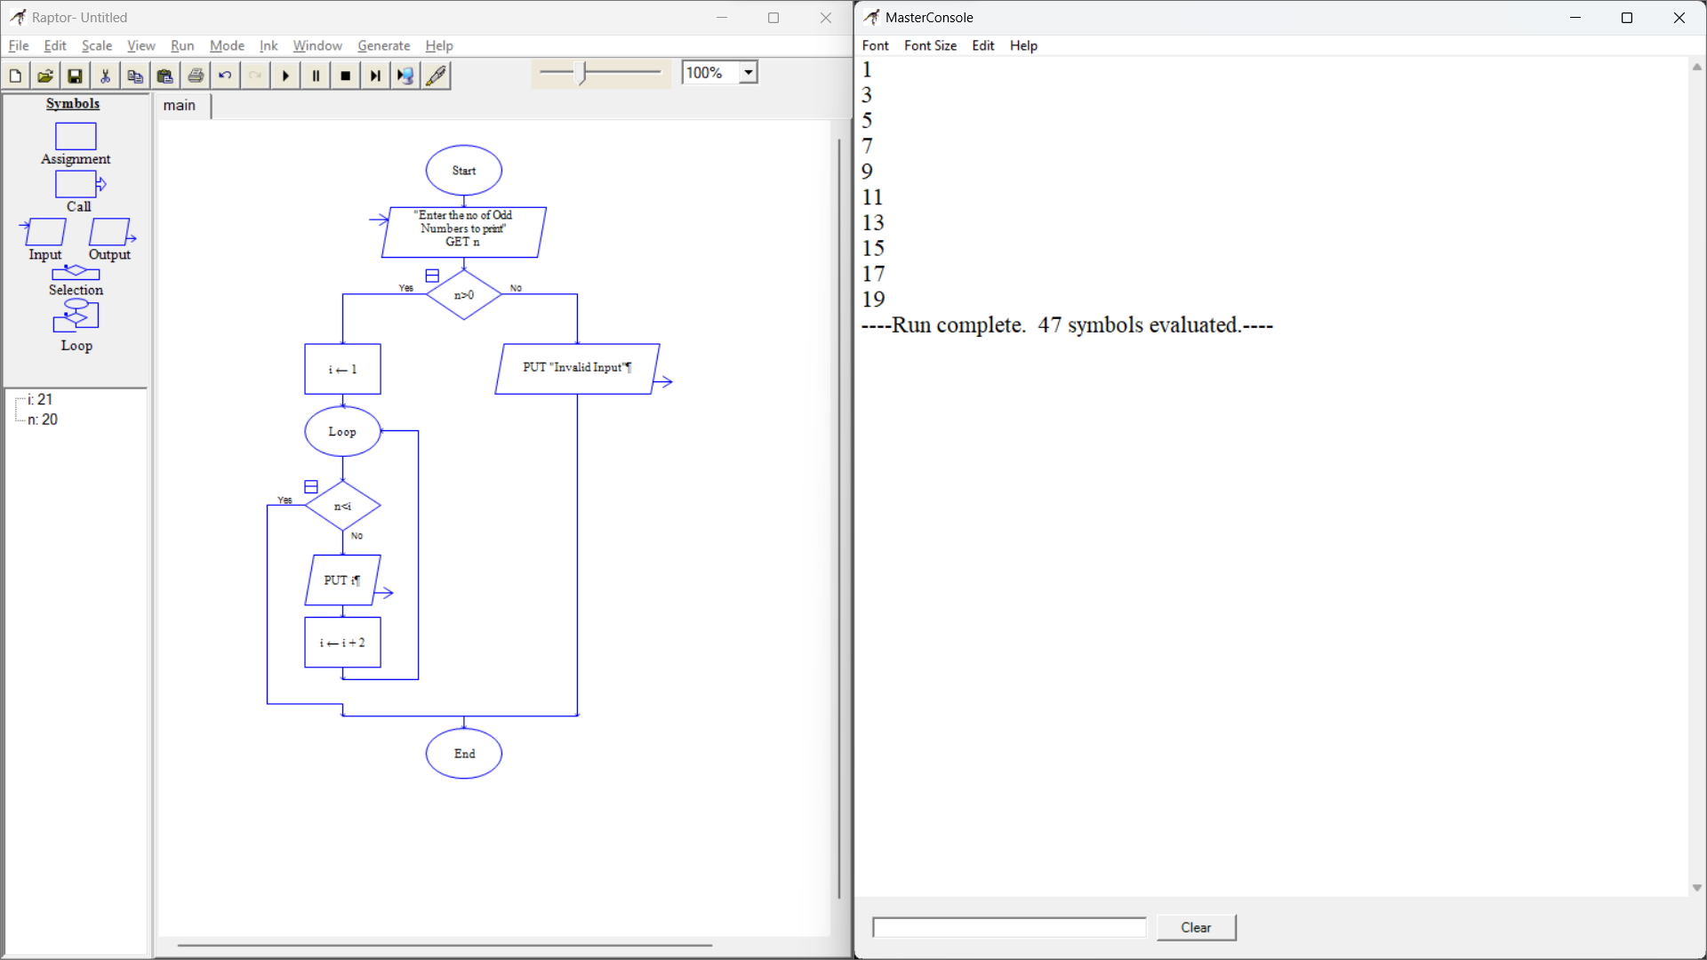

**32. Draw the flowchart that uses Raptor, how to reverse a given String.**

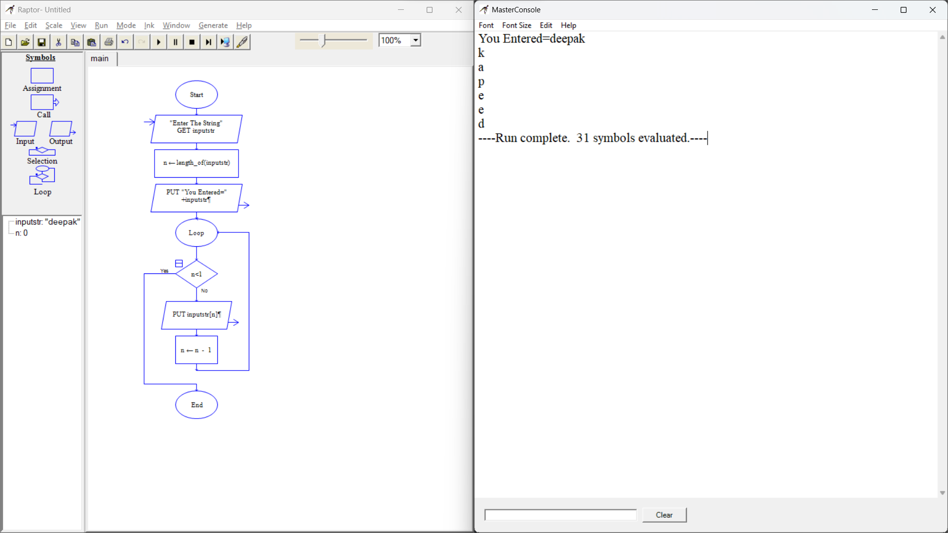

**33. Draw the flowchart using Raptor, The formula of the sum of first n natural numbers.**

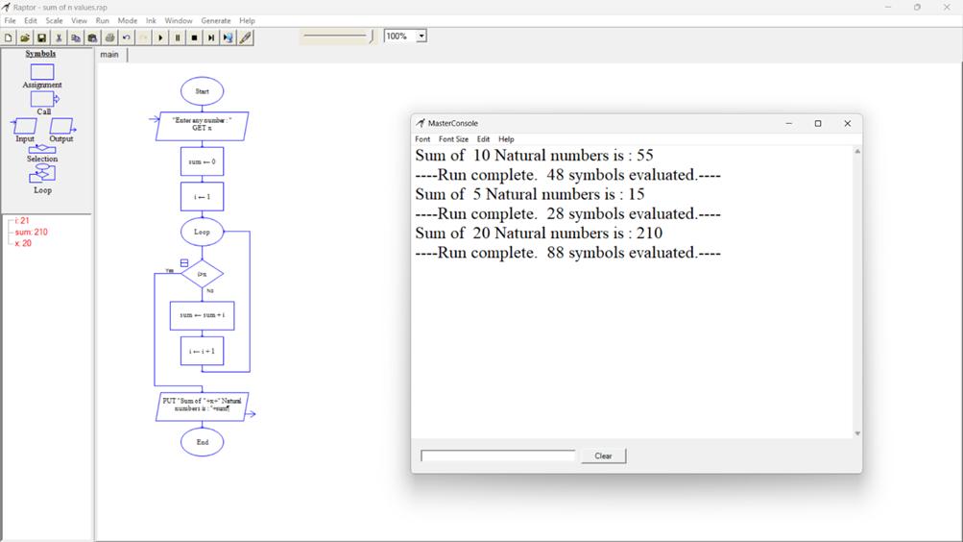

**34. Draw the flowchart using Raptor; Write a shell script to find the largest of n numbers in a range.**

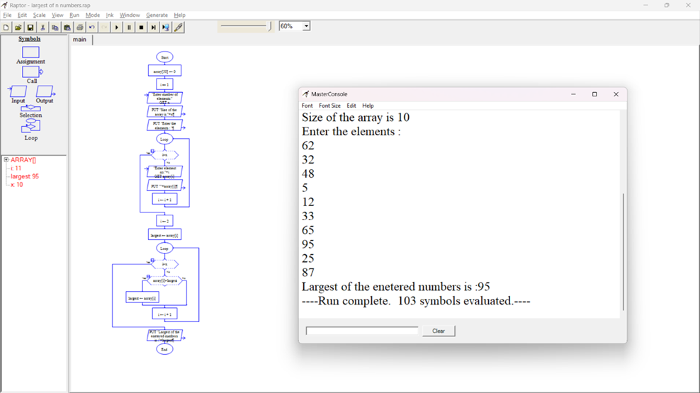

**35. Using Raptor- Draw and validate the flowchart to calculate Fibonacci Series.**

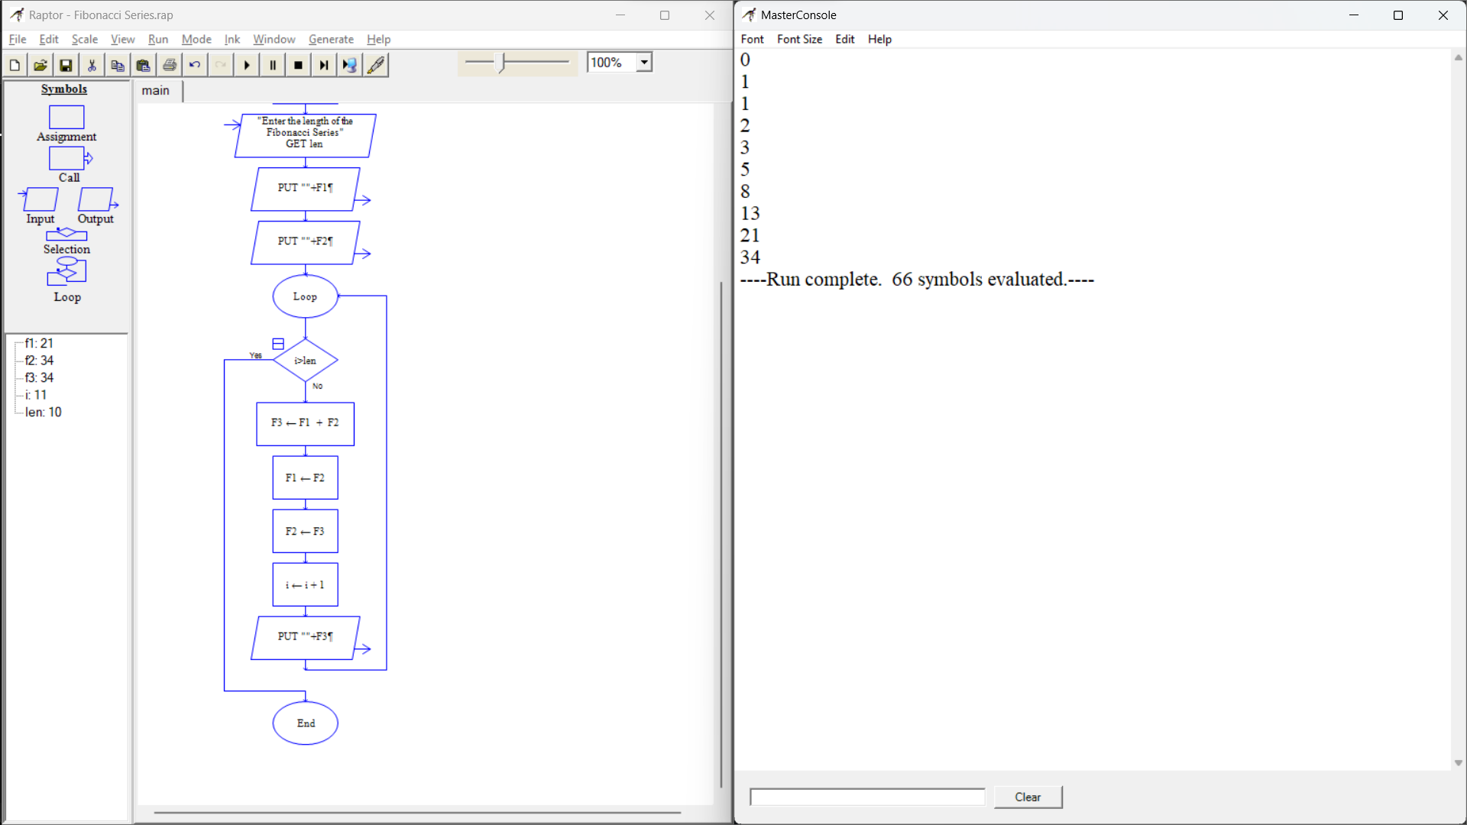

**36. Draw the flowchart using Raptor; given a number n find the smallest number evenly divisible by each number 1 to n.**

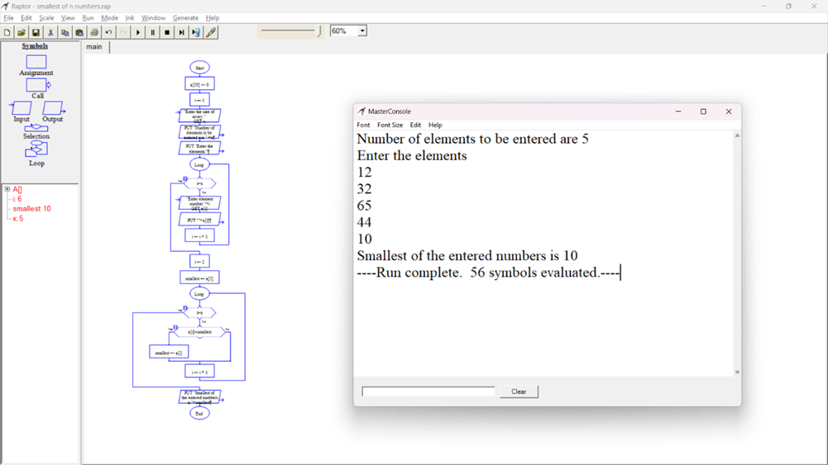

**37. E-wallet is an online prepaid account where one can stock money, to be used when required using Use case diagram.**

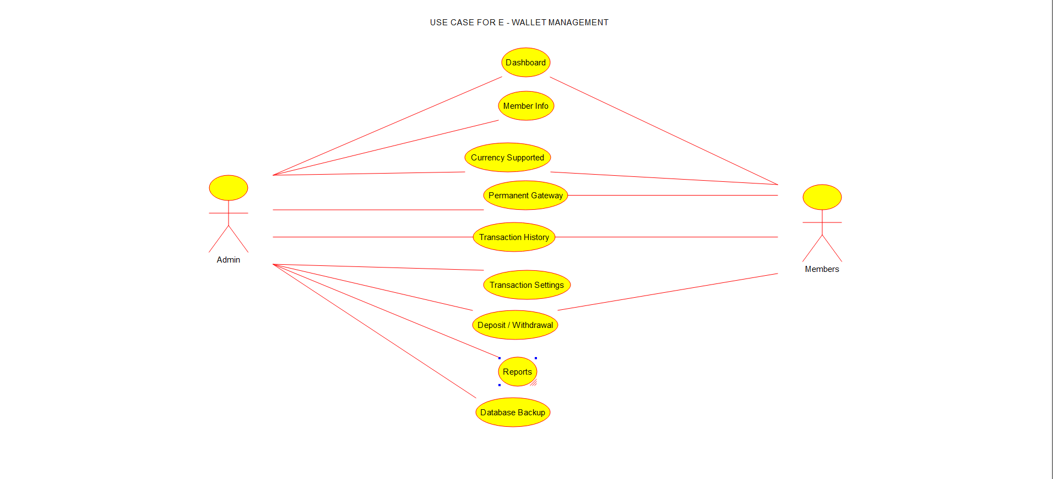

**38. A college has more than thousand security persons using Use case diagram.**

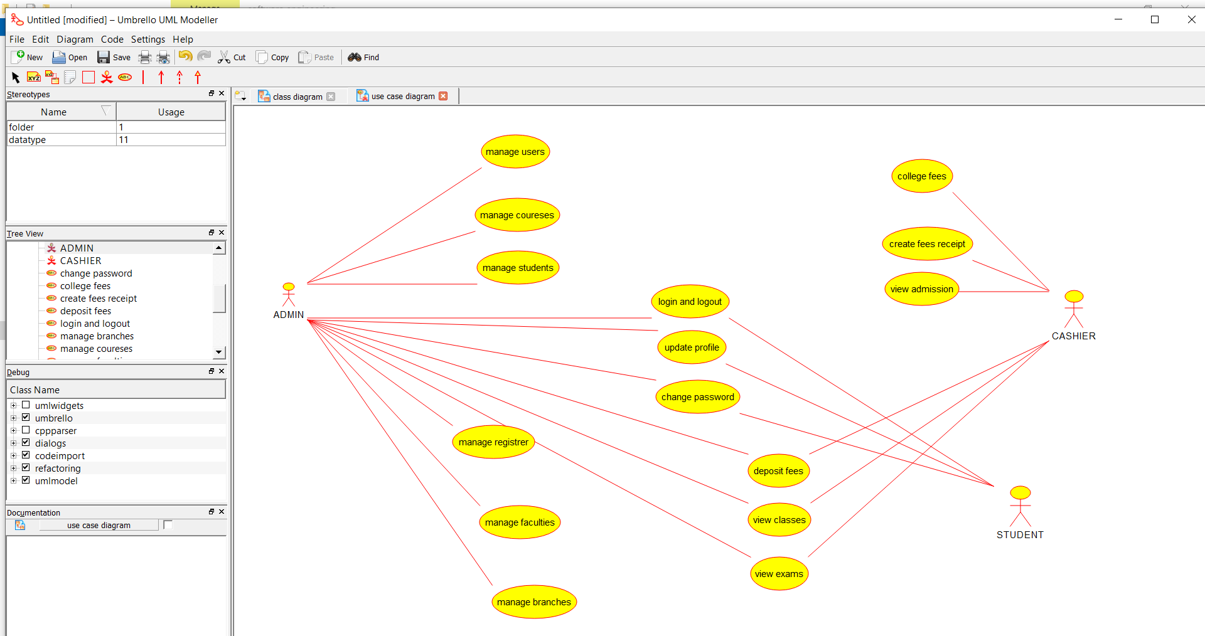

**39. The Internet has led to discussion of e-democracy and online voting using use case.**

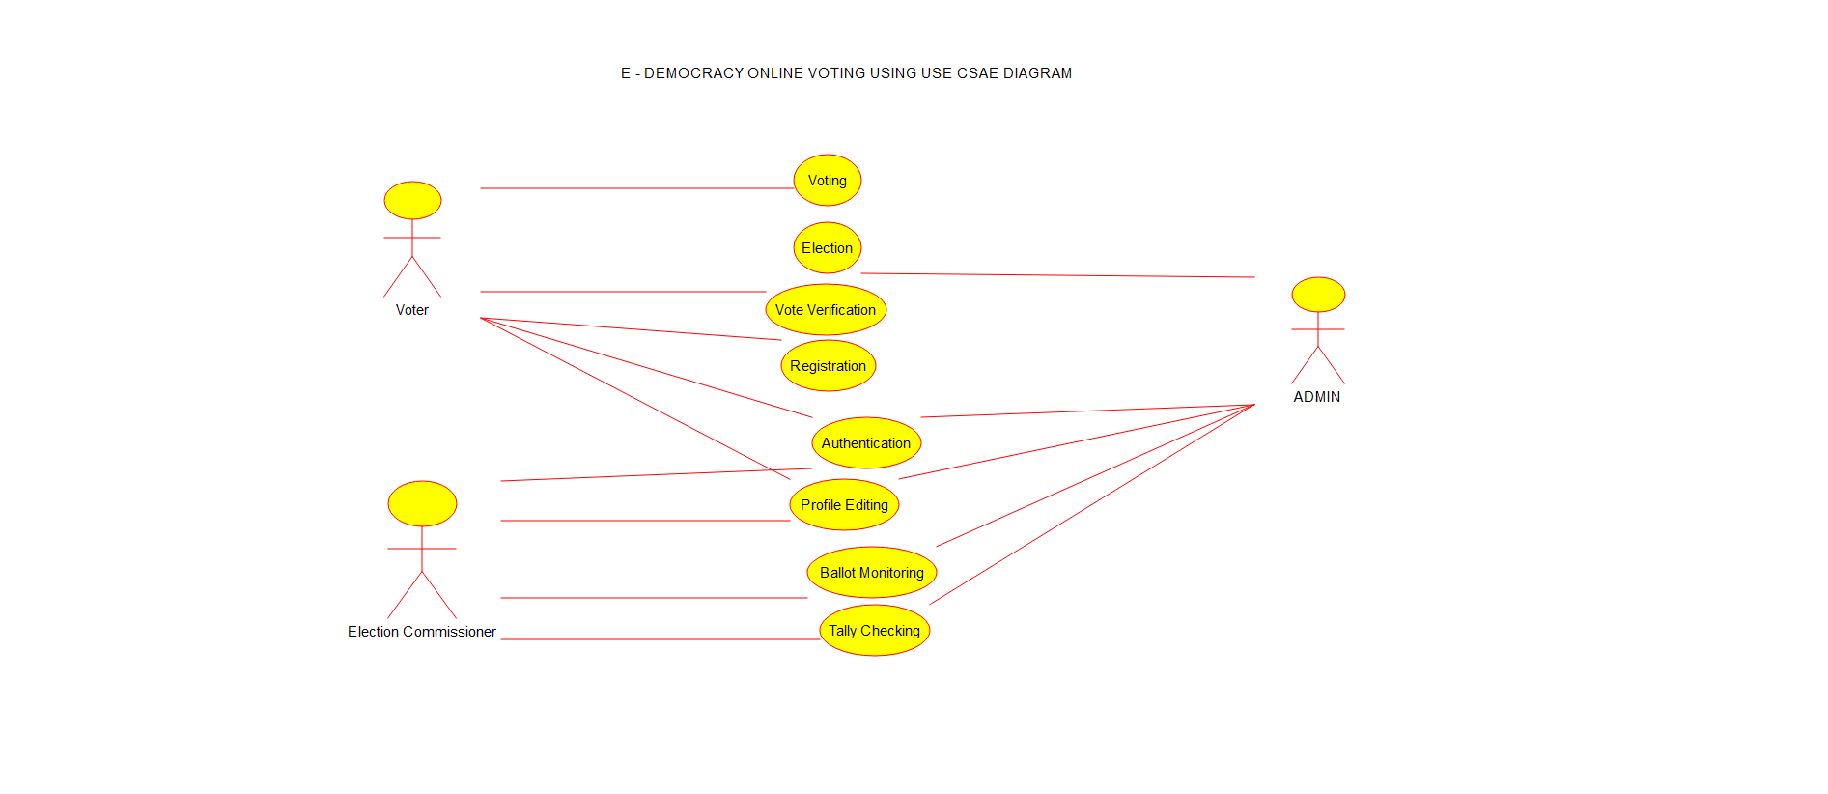

**40.**  **Using Raptor – Draw the flowchart to find largest of n numbers.**